SKILL AND JOB RECOMMENDER PNT2022TMID43075

Setting up Application Environment Install IBM Cloud CLI

|  |  |
| --- | --- |
| Date | 03 November 2022 |
| Team ID | PNT2022TMID43073 |
| Project Name | Customer care registry |

Step 1. First login with cloud.ibm.com,→Next search with Container Registry in ibm search catalog.

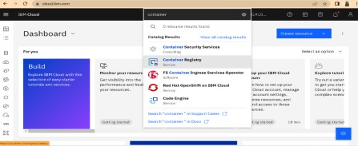

**Step 2** Next click Get started button → Next click Install the IBM Cloud CLI.

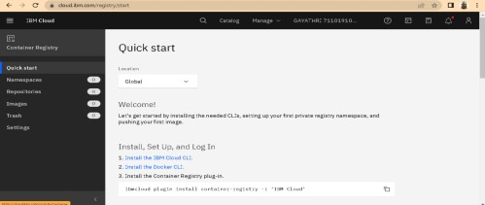

Step 3: I n cloud CLI there is list of commands insert the into our windows command prompt.

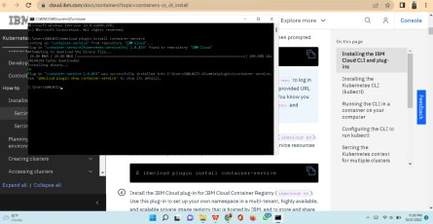

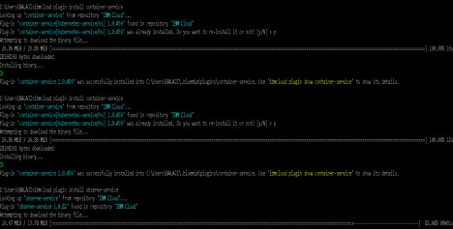

STEP 4: After entering all commands the cloud CLI installation is done.

